**Sub Domain Finder**

Submitted in partial fulfillment of the requirements for the award of degree of

**BACHELOR OF ENGINEERING**

**IN**

**COMPUTER SCIENCE & ENGINEERING**



**Submitted to:**

**Er. Kulvinder Singh**

**Submitted By:**

**Md. Azeem pasha**

**18BCS1391**

**DEPARTMENT OF COMPUTER SCIENCE & ENGINEERING**

**Chandigarh University, Gharuan**

**Implementation (100%):**

To run this module we need some requirements

A linux machine

Type the following command to view the options

* **python subdomain.py –help**

**OUTPUT:-**

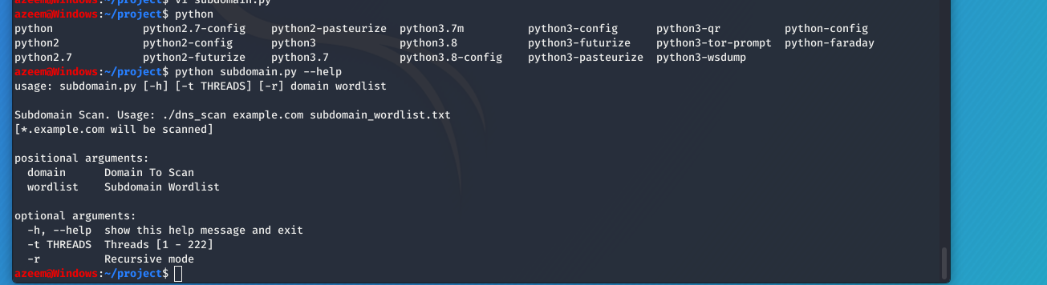

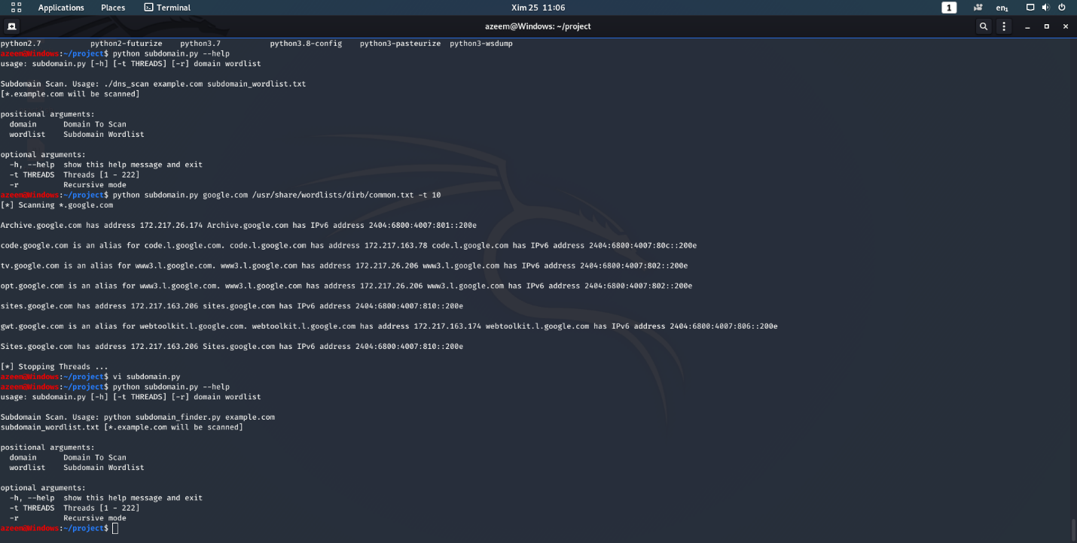

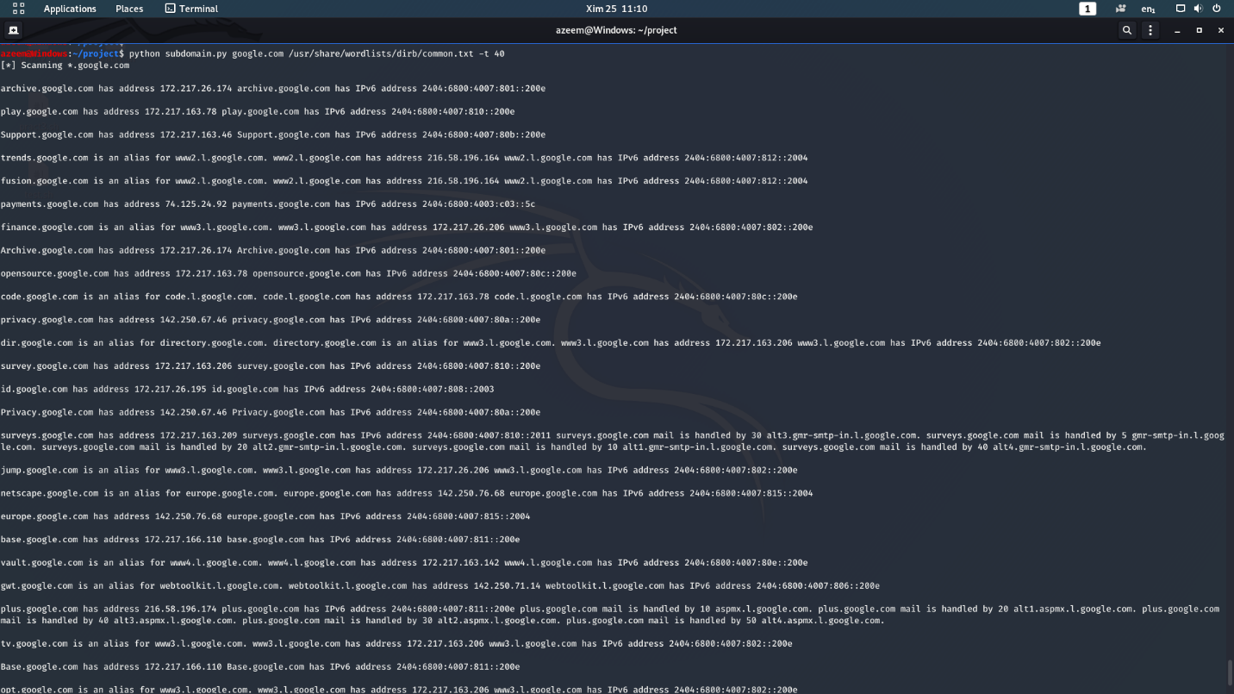

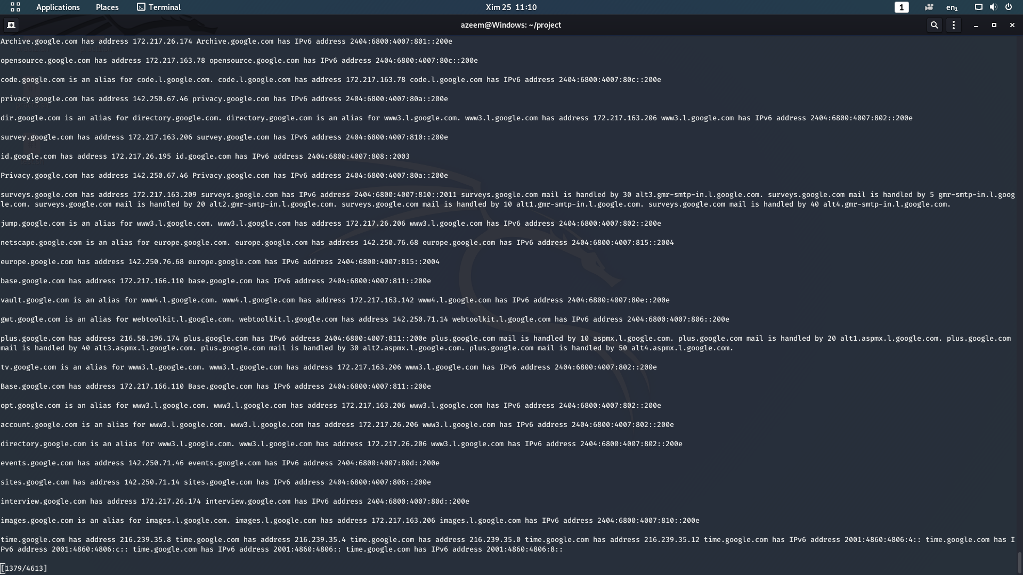

**Output Validation and Comparision:**

In the first test case the code was having a lot of errors. After trying so many test cases program ran successfully. This code bruteforce the subdomains with the existing wordlist in a given url.

**Team Work:**

This project is done by me. No people are involved.

**Md. Azeem Pasha 18BCS1391 18NTTP-1(B)**